David Cochran
2/24/10
Proposal for Part I

Purpose- This site is used for an easy quick access point to find information about a class.

Objective-
- To provide a schedule for due dates and activities that the class is holding.
- A place to contact Nancy Evans for questions, comments, or concerns.
- The site will provide course information; this will allow access to the syllabus of the course and see the brief overview of the class.
- The site will also show a brief history of what has been done in the class before.
- If interested in one of her courses people will be able to view what goes on in the course and see when things are due and show how things will happen in the course.
- And more.

Competitor Sites-
- http://kelley.iupui.edu/faculty/FacultyProfile.cfm?netid=plcochra This site has the Professor’s academic information and other awards and honors but no information on what he teaches. Only link on the page is the contact link to his phone, fax, or email. The pro is that you know a brief background of the person, and the con is you cannot dig deeper into what he teaches.
- http://drfd.hbs.edu/fit/public/facultyInfo.do?facInfo=ovr&facId=10677 This site is a professor from Harvard. The pro for this page is that it gives a lot of detailed information including his interests, biography, and current research. The con for his page is that the print is small and hard to read and doesn’t hold your attention very well.
- http://www.law.yale.edu/faculty/ABarak.htm This site is a professor from Yale University. This shows his brief educational history and how he came to Yale, then it goes on to tell the courses that he teaches. The pro of this is that you find out that he studied law in Jerusalem, and his degrees. The con is that there is nothing else to base off of then a paragraph and a picture.

Our Advantage- The advantage we have is that we actually have our own website rather than a link off someone else’s. Another advantage is that we will show course information, schedule, projects, and others. This will let the viewer go deeper and find out more information to get them interested. One last advantage is that we can design the web site however we want to catch the attention of the viewer, while the other professors could not choose at all.

Target Audience- Are target audience will be high school students that have just signed up for the course, or they are interested in the courses and are looking for more information. Another audience that will be interested in this site will be college students looking to get some credits through online and are trying to find information on the course or who to contact.

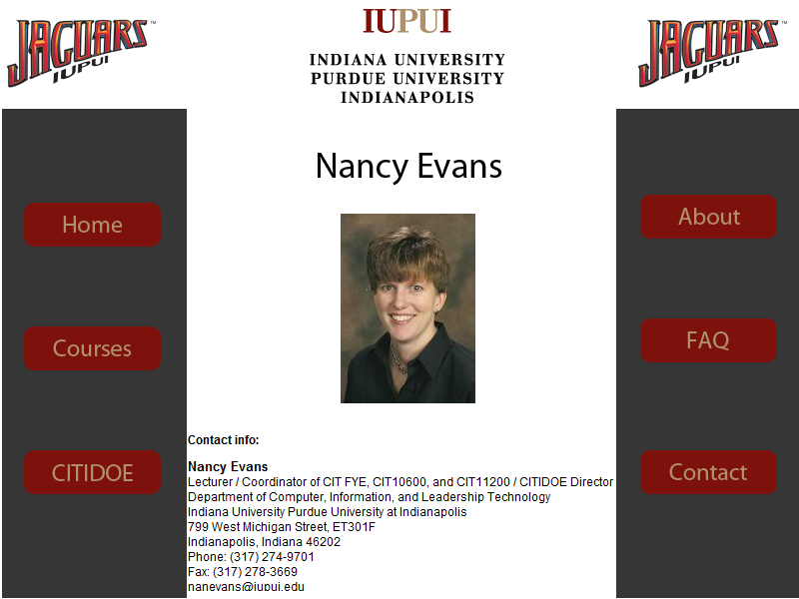
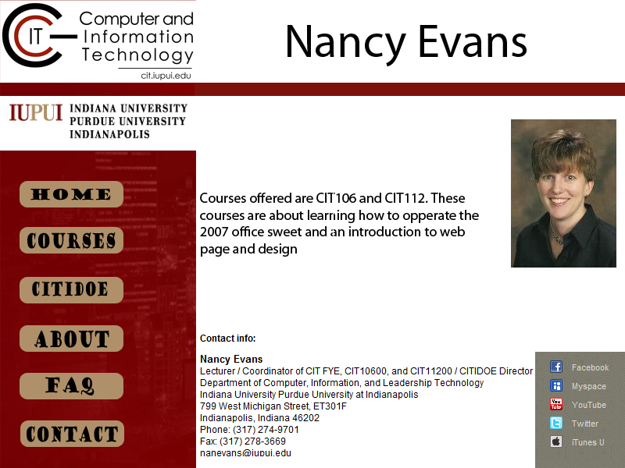

Principle Under graduate

Home Page
Contact
FAQ
About
http://cit.iupui.edu/citidoe/
Cit112
Info
Cit106
Info
Cit112

Cit106
What are these
What you’ll learn
Cit112 Syllabus

Cit106 Syllabus
Principle Under graduate
What are these
What you’ll learn
Courses
CITIDOE Info

Principle under Graduate
What are these
What you’ll learn

